

Curitiba, ________ de __________________________ de 2024

Estudante:______________________________________ 8º ano ___ EF af

Geografia – Professora Morgana Lopes

**GUIA DE REVISÃO – 1º TRIMESTRE**

Descreva os critérios e cite as regiões compreendidas nas seguintes formas de Regionalização:

1. Regionalização Continental:

________________________________________________________________________________________________________________________________________________________________________________________________________________________________________________________________________________________________________________________________________________________

1. Regionalização Histórica-geográfica:

________________________________________________________________________________________________________________________________________________________________________________________________________________________________________________________________________________________________________________________________________________________

1. Regionalização no Imperialismo:

________________________________________________________________________________________________________________________________________________________________________________________________________________________________________________________________________________________________________________________________________________________

1. Regionalização da Guerra Fria/Sistêmica:

________________________________________________________________________________________________________________________________________________________________________________________________________________________________________________________________________________________________________________________________________________________

1. Regionalização Norte-Sul:

________________________________________________________________________________________________________________________________________________________________________________________________________________________________________________________________________________________________________________________________________________________

Diferencie os termos relativos à Demografia:

1. População absoluta e População relativa:

__________________________________________________________________________________________________________________________________________________________________________________________________________________________________________________________________

1. Populoso e Povoado:

__________________________________________________________________________________________________________________________________________________________________________________________________________________________________________________________________

1. Natalidade e Mortalidade:

__________________________________________________________________________________________________________________________________________________________________________________________________________________________________________________________________

Descreva os seguintes eventos da dinâmica da população mundial:

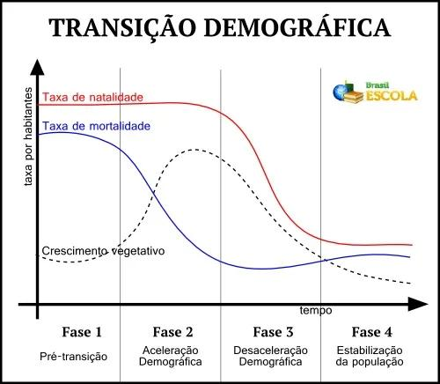

1. “Baby Boom” – Período entre 1946 a 1964:

________________________________________________________________________________________________________________________________________________________________________________________________________________________________________________________________________________________________________________________________________________________

1. Diminuição da fecundidade mundial – A partir de 1964:

________________________________________________________________________________________________________________________________________________________________________________________________________________________________________________________________________________________________________________________________________________________