

Curitiba, ________ de __________________________ de 2024

Estudante:______________________________________ 9º ano ___ EF af

Geografia – Professora Morgana Lopes

**GUIA DE REVISÃO – 1º TRIMESTRE**

Sobre o processo de Globalização, responda:

1. O que é Globalização?

__________________________________________________________________________________________________________________________________________________________________________________________________________________________________________________________________

1. Quais são as vantagens da globalização?

________________________________________________________________________________________________________________________________________________________________________________________________________________________________________________________________________________________________________________________________________________________

1. Quais são as desvantagens da globalização?

________________________________________________________________________________________________________________________________________________________________________________________________________________________________________________________________________________________________________________________________________________________

1. Quais são as prováveis origens da Globalização?

______________________________________________________________________________________________________________________________________________________________________________________________________________________________________________________________________________________________________________________________________________________________________________________________________________________________________________

1. Quais são as tecnologias que possibilitaram o desenvolvimento da Globalização?

______________________________________________________________________________________________________________________________________________________________________________________________________________________________________________________________________________________________________________________________________________________________________________________________________________________________________________

Sobre a Expansão do Capitalismo e as Revoluções Industriais, defina:

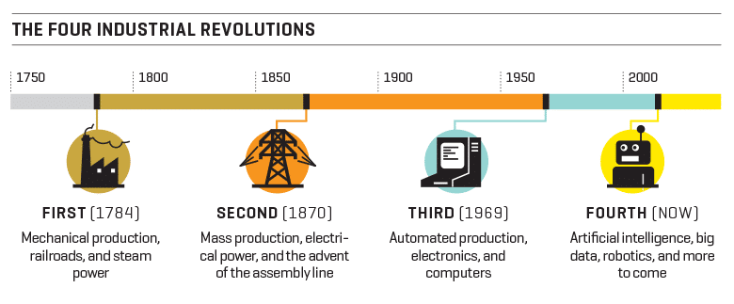

1. Primeira Revolução Industrial:

__________________________________________________________________________________________________________________________________________________________________________________________________________________________________________________________________

1. Segunda Revolução Industrial:

__________________________________________________________________________________________________________________________________________________________________________________________________________________________________________________________________

1. Terceira Revolução Industrial:

__________________________________________________________________________________________________________________________________________________________________________________________________________________________________________________________________

1. Quarta Revolução Industrial:

________________________________________________________________________________________________________________________________________________________________________________________________________________________________________________________________________________________________________________________________________________________

1. Quais foram as fases do capitalismo? Descreva-as brevemente.

____________________________________________________________________________________________________________________________________________________________________________________________________________________________________________________________________________________________________________________________________________________________________________________________________________________________________________________________________________________________________________________________________________________________________________________________________________________________________________________________________________________________________________________________________________________________________________________________________________________________________________________________________________________________