** COLÉGIO NOSSA SENHORA DE SION**

Teacher: Ms. Aquino Subject: English Language

Student´s full name: _______________________ Date: ________

**GUIDE LESSON – WEEK FROM MAY 20TH TO 29TH - 8º GRADE**

**1**

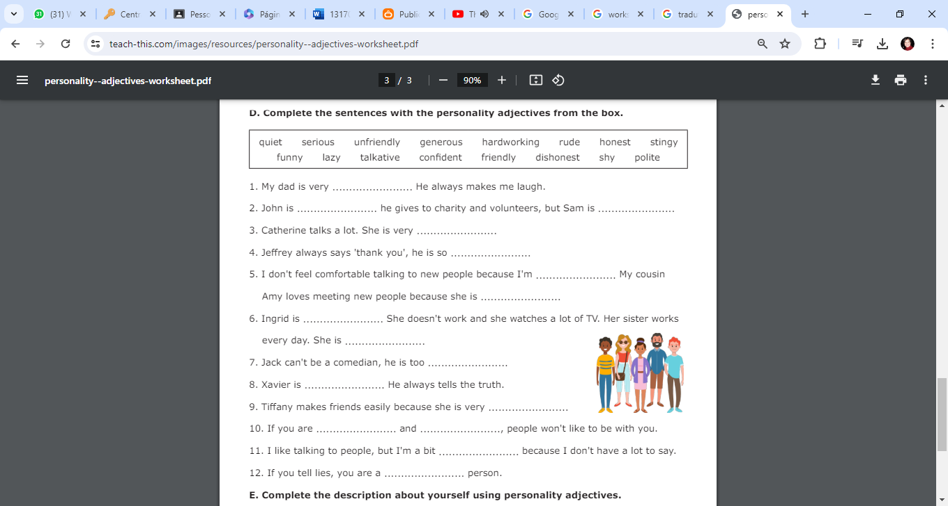

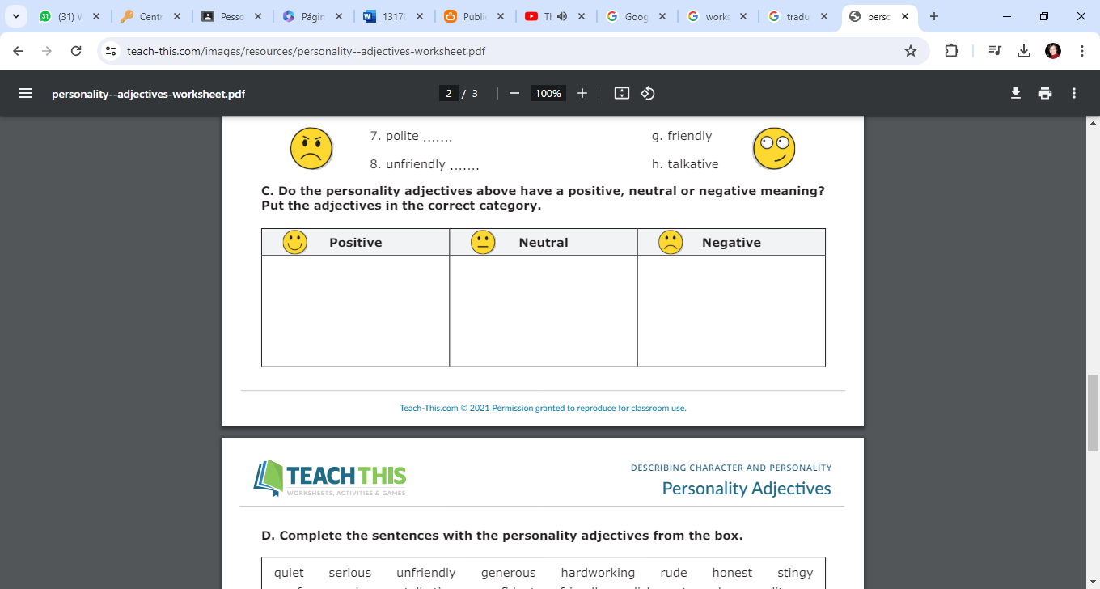

**2**