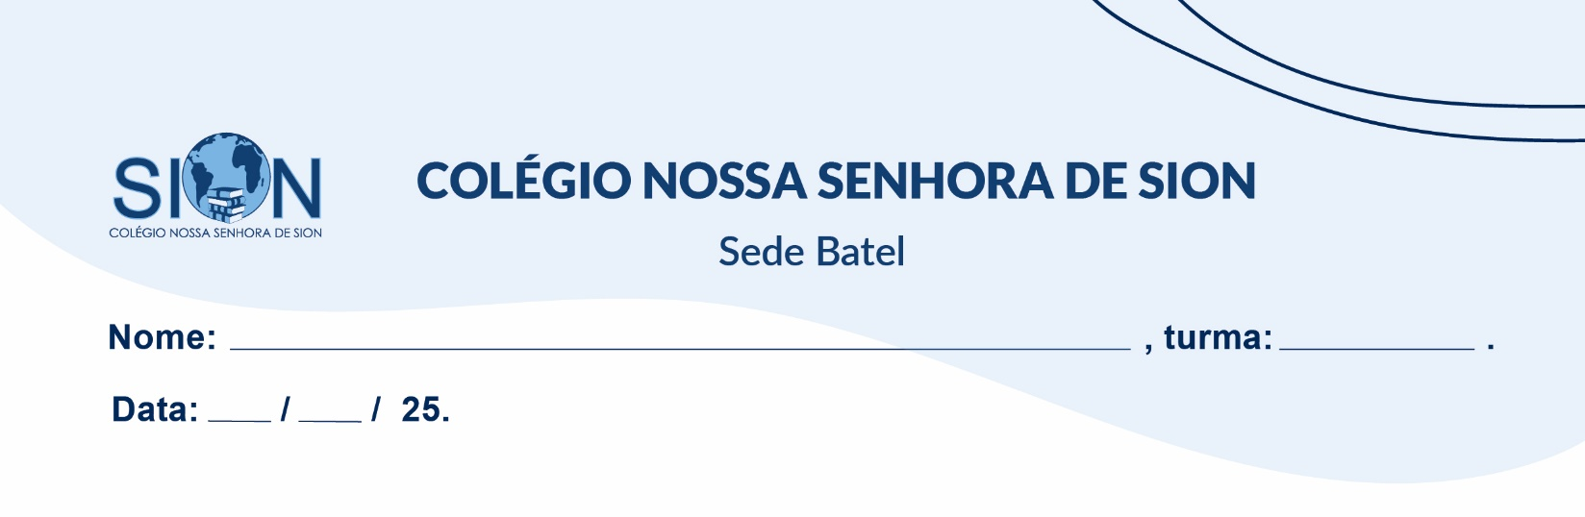

**Subject English**

**Ms. Kauane**

**GUIDE LESSON– 1º GRADE – 1º TRIMESTER**

01. Put the dialogue in the correct order (1 to 6).

( )Alice: Well, he's tall with dark hair and blue eyes

( )Alice: Have you met our new neighbour?

( )Bob: No, not yet. What's he like?

( )Alice: Yes, very friendly. He introduced himself and even offered to help with our groceries.

( )Bob: That's nice of him. I'll make sure to say hello next time I see him.

( )Bob: Oh, I think I saw him the other day. Is he friendly?

02. Connect the question with the correct answer.

A) How often does your brother style his hair? ( ) He goes after work.

B) Does your sister enjoy drawing? ( ) Yes, he does.

C) When does your dad go to the gym? ( ) He styles it every day.

D) What is your favorite after-school activity? ( ) yes, she does.

E) Does Peter walk to school? ( ) I like to play video games after school.

03. Circle the correct options.

a) I **watch / ’m watching** a reality show now.

b) We always **have / are having** football practice on Thursdays.

c) Ryan always **has / is having** a lot of friends.

d) You **aren’t listening / don’t listen** to me at the moment!

e) Max **makes / is making** dinner right now.

04. Complete the sentences with the present continuous form of the verbs in parentheses.

a) I ________________________ (read) an interesting book.

b) Charlotte _______________________ (arrive) now.

c) My parents ____________________ (listen) to music.

d) You ____________________ (not do) your homework now.

e) The cat _____________________ (not drink) milk.

f) I _______________________ (sit) on the sofa.