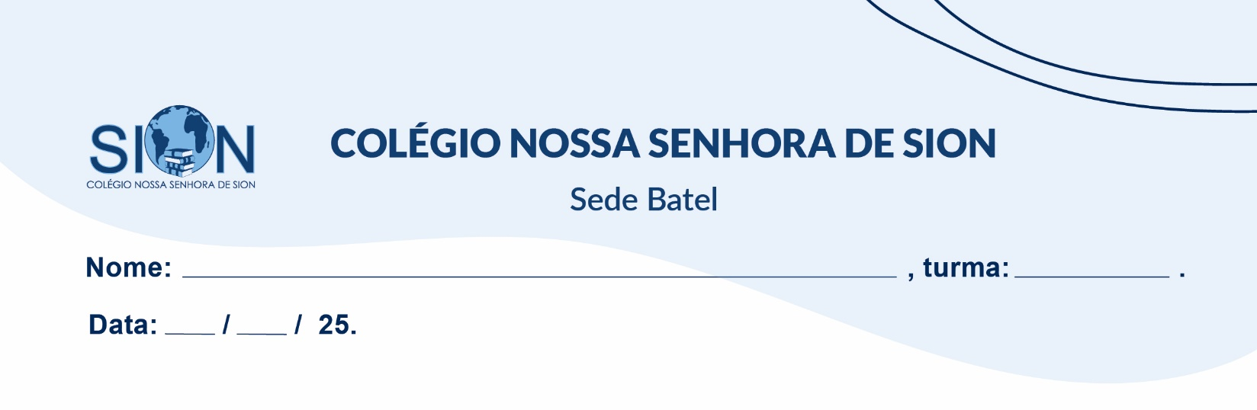

**Subject English**

**Ms. Kauane**

**GUIDE LESSON– 1º GRADE – 1º TRIMESTER**

Read the text and answer questions 01 to 04.

**The surprising history of India’s vibrant sari tradition**

South Asian women have draped themselves in colorful silks and cottons for eons. The ways they’re made and worn are dazzling and diverse.

The word “sari” means “strip of cloth” in Sanskrit. But for the Indian women – and a few men – who have been wrapping themselves in silk, cotton, or linen for millennia, these swaths of fabric are more than just simple garments. They’re symbols of national pride, ambassadors for traditional (and cutting-edge) design and craftsmanship, and a prime example of the rich differences in India’s

29 states.

“The sari both as symbol and reality has filled the imagination of the subcontinent, with its appeal and its ability to conceal and reveal the personality of the person wearing it,” says Delhi-based textile historian Rta Kapur Chishti, author of Saris of India: Tradition and Beyond and co-founder of Taanbaan, a fabric company devoted to reviving and preserving traditional Indian spinning and weaving methods.

The first mention of saris (alternately spelled sarees) is in the Rig Veda, a Hindu book of hymns dating to 3,000 B.C.; draped garments show up on Indian sculptures from the first through sixth centuries, too. What Delhi-based textile historian Rta Kapur Chishti calls the “magical unstitched garment” is ideally suited to India’s blazingly hot climate and the modest-dress customs of both Hindu and Muslim communities. Saris also remain traditional for women in other South Asian countries including Pakistan, Bangladesh, and Nepal.

(Available in: https://www.nationalgeographic.com/travel/photography/the-story-of-the-sari-in-india/.)

01. Based on the text, what does the sari represent beyond being a simple piece of clothing?

a) A practical garment that has remained unchanged throughout history

b) A cultural symbol that reflects India's national pride and craftsmanship

c) A fashion trend that originated in the 19th century

d) A religious item worn exclusively by Hindu women

02. Why does textile historian Rta Kapur Chishti describe the sari as a "magical unstitched garment"?

a) Because it allows for flexibility in style and adaptation to different body types

b) Because it is woven using secret techniques passed down for generations

c) Because it is made from a single continuous piece of cloth without any seams

d) Because it symbolizes the magical heritage of Hindu mythology

03. Which of the following statements about the historical significance of saris is accurate?

a) They first appeared in religious scriptures and ancient sculptures, dating back thousands of years

b) They were introduced during British colonial rule as part of India's textile industry

c) They have always been exclusive to Hindu culture and were later adopted by other South Asian countries

d) They are only mentioned in modern literature, with no historical references before the 19th century

04. What can be inferred about the sari’s adaptability in Indian society?

a) It remains unchanged despite regional differences in fabric, color, and draping style

b) It has evolved to reflect both traditional and contemporary designs across different states

c) It has gradually been replaced by Western-style clothing among Indian women

d) It is worn exclusively by older generations, with younger individuals abandoning it

05. Choose the correct form of the verb simple present or present continuous.

a) Indian women wear / are wearing saris on special occasions.

b) Right now, a famous designer creates / is creating a new sari collection.

c) The textile industry produce / produces thousands of saris every year.

d) At the moment, she buy / is buying a handmade silk sari.

e) Traditional artisans weave / are weaving saris with unique patterns every day.