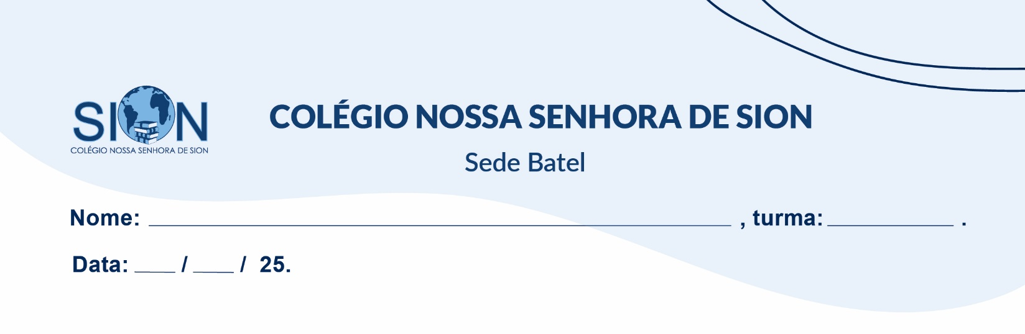

**Subject English**

**Ms. Kauane**

**GUIDE LESSON– 2º GRADE – 1º TRIMESTER**

Read the text and answer questions

Nineties fashion was hard to pin down. A clash of trends screamed for our attention while others were so quietly cool they're still sartorial staples in our collective wardrobes: slip dresses, Doc Martens, chokers, crop tops.

While the 1980s were all about volume – padded shoulders, puffed jackets, big hair and an obsession with designer wear –style in the early 1990s was decidedly low maintenance.

(Available in: https://edition.cnn.com/style/article/1990s-fashion-history/index.html.)

01. What is the main idea of the passage?

a) The 1990s fashion was entirely chaotic and had no defining styles.

b) The 1990s fashion was a mix of trends, some loud and others understated.

c) The 1990s fashion followed the same patterns as the 1980s.

d) The 1990s fashion was only focused on designer brands.

02. According to the passage, how did 1980s fashion compare to early 1990s fashion?

a) The 1980s emphasized minimalism, while the 1990s focused on extravagance.

b) The 1980s had an obsession with volume and designer wear, whereas the 1990s were more low-maintenance.

c) Both decades prioritized oversized fashion and designer brands.

d) The 1990s completely rejected all fashion trends from the 1980s.

03. Which of the following fashion items is NOT mentioned as a part of 1990s fashion?

a) Slip dresses

b) Doc Martens

c) Chokers

d) High-waisted jeans

04. What does the phrase "sartorial staples in our collective wardrobes" suggest?

a) Some 1990s fashion trends are still commonly worn today.

b) All 1990s fashion items are outdated.

c) The 1990s fashion was only relevant in that decade.

d) Fashion trends from the 1990s were short-lived.

05. What is the author’s tone in the passage?

a) Criticizing the lack of structure in 1990s fashion.

b) Nostalgic and informative about the evolution of fashion.

c) Mocking the trends of the 1980s and 1990s.

d) Neutral and detached, avoiding any evaluation.