

**Subject English**

**Ms. Kauane**

**ENGLISH WORKSHEET– 6º GRADE – 1º TRIMESTER**

1. Look for the words below and color them with a colored pencil.

**AUNT- MOTHER- FATHER- SISTER-BROTHER-NIECE-NEPHEW-PARENTS-SON-DAUGHTER-COUSIN**

|  |  |  |  |  |  |  |  |  |  |
| --- | --- | --- | --- | --- | --- | --- | --- | --- | --- |
| A | U | N | T | A | V | U | N | T | F |
| B | D | A | U | G | H | T | E | R | A |
| B | R | F | P | A | R | E | N | T | S |
| R | O | A | S | R | E | H | E | C | I |
| O | T | T | S | O | N | S | P | O | S |
| T | H | H | F | M | I | W | H | U | T |
| H | E | E | U | I | E | Q | E | S | E |
| E | M | R | U | N | C | E | W | I | R |
| R | M | O | T | H | E | R | S | N | N |

02. Draw your family tree. It must contain the family member's name and their relationship to you.

03. Describe the picture.

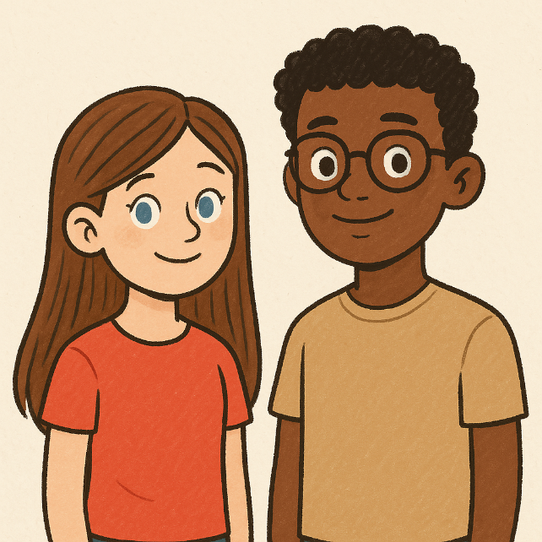

Anna: ________________________________________________________________________________

Peter: ________________________________________________________________________________

04. Read the text and answer.

Sophie’s Daily Routine

Sophie is eleven years old and she lives in Brighton, England. She usually gets up at a quarter to eight, she has a shower, gets dressed and then she brushes her teeth. After that, she goes downstairs and has breakfast. For breakfast she usually has milk, toast and orange juice. Then she brushes her teeth again because she likes them white and healthy!

Then she grabs her school bag and goes to the bus stop to catch the school bus. Classes start at half past eight and finish at half past four. She usually has lunch at the school canteen with her schoolmates at about 12 o’clock. Her best friend is Amy and Sophie always sits next to her at lunch.

After school she returns home and does her homework. She is a very hard-working pupil and she never misses a school task! After homework, she usually listens to music and watches television a bit.

At half past seven it is time for dinner. Then she usually reads a book or chats with her parents for a while. Finally, she goes to bed at about ten o’clock, but before that she brushes her teeth. Sophie is a happy little girl!

a) Order Sophie’s daily routine.

_______ She goes to bed at about ten o’clock.

_______ She gets dressed.

_______ She catches the bus to school.

_______ She has lunch at the school canteen.

_______ She listens to music.

_______ She gets up.

_______ She does her homework.

_______ She has a shower.

_______ She has dinner.

b) Write T for true and F for false.

( ) Sophie is twelve years old.

( ) Sophie lives in Brighton, England.

( ) She usually gets up at eight o'clock.

( ) Sophie has a shower and then brushes her teeth.

( ) For breakfast, she usually has milk, toast, and orange juice.

( ) Sophie brushes her teeth once a day.

05. Rewrite the sentences in question and negative form.

a) I have a new backpack.

__________________________________________________________________________________________________________________________________________________________________________

b) You have two brothers.

__________________________________________________________________________________________________________________________________________________________________________

c) He has a cool bike.

__________________________________________________________________________________________________________________________________________________________________________

d) We have English class on Mondays.

__________________________________________________________________________________________________________________________________________________________________________

e) She has long hair.

__________________________________________________________________________________________________________________________________________________________________________