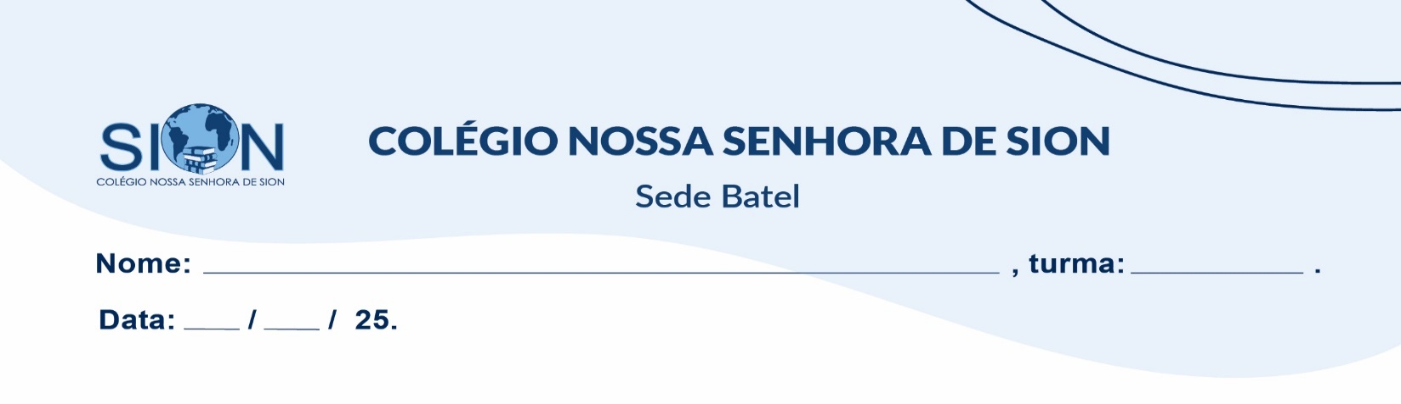

**Subject English**

**Ms. Kauane**

**ENGLISH WORKSHEET– 7º GRADE – 1º TRIMESTER**

01. Choose the correct option according to the image.

|  |
| --- |
| a) Talk show  b) Drama  c) Cartoon |
| a) Talk show  b) Sport show  c) Cooking show |
| a) Soap opera  b) Drama  c) Cooking show |
| a) Talk show  b) Game show  c) The News |
| a) The News  b) Reality show  c) Streaming series |

02. Write a sentence in the present continuous for each word.

a) Run: _______________________________________________________________________________

b) Study: ______________________________________________________________________________

c) Have: _____________________________________________________________________________

d) Do: ________________________________________________________________________________

03. Write a sentence in the simple presente for each word.

a) Always: ____________________________________________________________________________

b) Often: ______________________________________________________________________________

c) Sometimes: _________________________________________________________________________

d) Never: _____________________________________________________________________________

04. Read the text and answer the questions below.

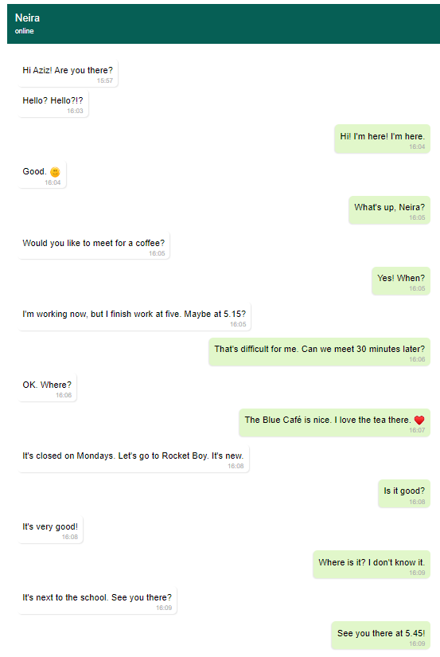

1. What does Neira want to do?

( ) Go to a café

( ) Go to a cinema

( ) Go to a class

1. What time does Neira finish work?

( ) Five o'clock

( ) A quarter past five

( ) A quarter to five

1. Where are they going to meet?

( ) The Blue Café

( ) Rocket Boy

( ) The school

05. Match the words with the images.

|  |  |  |  |
| --- | --- | --- | --- |
| rainy | sunny | cloudy | foggy |

|  |  |
| --- | --- |
| _______________________________ | __________________________________ |
| ______________________________ | __________________________________ |