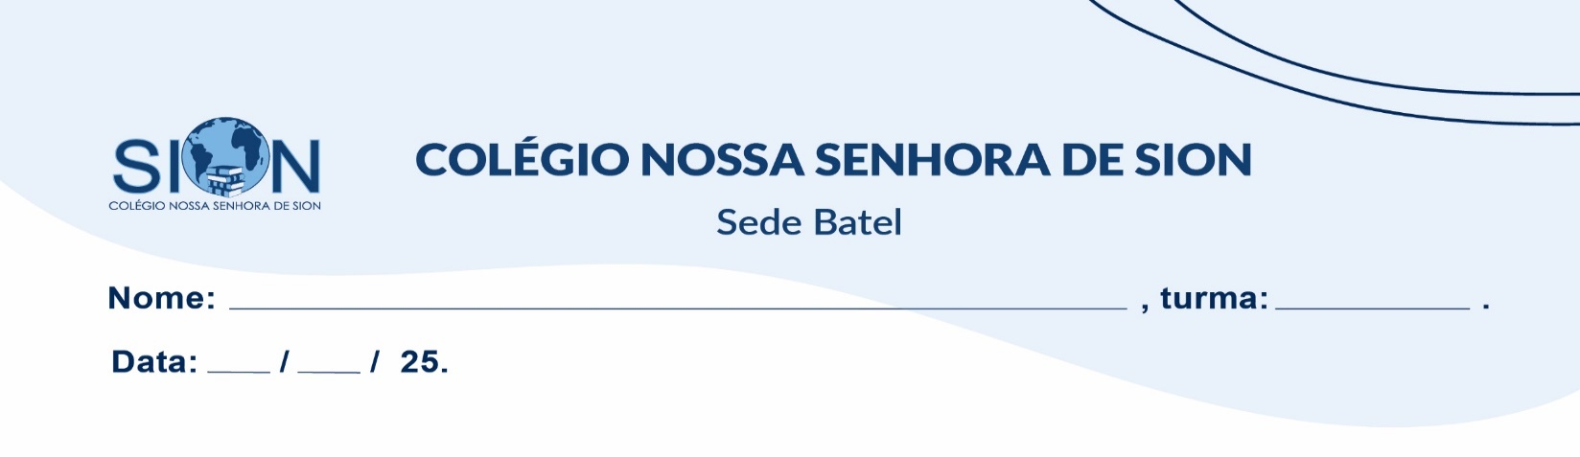

**Subject English**

**Ms. Kauane**

**ENGLISH WORKSHEET– 8º GRADE – 1º TRIMESTER**

Read the text and answer questions **01 to 05**.

**Tips For Travelling Alone**

Travelling alone seems scary if it’s the first time you are going to leave the comfort of home. You will probably think about the potential risks or difficult situations. What happens if I get ill, or have an accident? Isn’t it dangerous to go out alone at night? What happens if I get attacked? Isn’t it strange to eat at restaurants alone all the time?

Most travellers have these worries and more before their first trip alone, but all these fears disappear when they see all the benefits of this great experience. Here I’m going to give you 3 tips on how to travel alone and have a good time.

Speak the language

Humans are sociable creatures. We all need to talk to other people. If you are travelling alone, it’s a good idea to go somewhere you speak the language.

Sleep with the locals

Hotels are comfortable but very lonely, and hostels are perfect for people who travel alone, but you will only speak with other tourists. Try to rent a room in an apartment. This will give you a connection with local residents and they can give you a lot of tips on what you can do.

Don’t be shy

Don’t be afraid of asking. Ask for directions in the street, or ask about the place, the culture or the customs to the local people that you find in bars, parks, etc. You will be surprised how much people like to talk about their town or their culture. Remember you are alone. Asking can be an effective way to start a conversation and meet new people.

01. The writer **thinks that travelling alone is**...

a) worse than staying at your comfortable home.

b) dangerous.

c) a good idea.

02. The **writer wants to**...

a) help people who want to travel alone.

b) talk about the possible risks of travelling alone.

c) talk about his or her experiences travelling.

03. If you travel alone, **it’s a good idea**...

a) to learn the language of the place before you go there.

b) to go to a place where you can speak their language.

c) to speak to other tourists.

04. The writer thinks that if you travel alone, **hostels are**...

a) the best option.

b) very good but not the best option.

c) worse than hotels.

05. What is the **best thing about asking**?

_____________________________________________________________________________________

_____________________________________________________________________________________

06. Turn the **following sentences into questions in the past continuous**.

a) They have dinner.

_____________________________________________________________________?

b) I listen to music.

_____________________________________________________________________?

c) We watch TV together.

_____________________________________________________________________?

d) It was raining.

______________________________________________________________________?

e) The dog barks.

______________________________________________________________________?

f) All the pupils participate in class. ______________________________________________________________________?

07. Complete the text. **Use the Simple Past or the Past Continuous.**

It _____________(be) a rainy day of November. We________________ (come) from school at 2o’clock.

We __________________ (not be) very hungry but we ____________________ (be) too cold.

While we __________________ (walk) with my umbrella, we ____________________ (find) a coin.

It ____________________(not be) a normal coin, it ______________________ (be) a strange coin.

We _________________ (not continue) walking. We ____________________ (be) a bit nervous. What should

08. **Match the words with the meanings.**

a) grumpy

b) sensible

c) lazy

d) helpful

e) confident

f) silly

g) untalented

**Meanings:**

( ) not good at doing things

( ) always ready to help

( ) believes in themselves

( ) gets angry or annoyed easily

( ) doesn’t like to work

( ) acts in a funny or foolish way

( ) makes smart decisions

09. Write an email telling a friend about something that happened in the past. Use Simple Past, Past Continuous and Used to. Your text must have a minimum of 50 words and a maximum of 100.

EX:



  
  
  
  
  
  
  
  
  
  
  
  
  
  
  
  
  
  
  
  