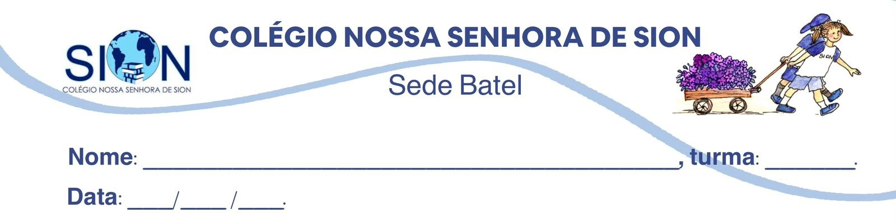

Subject English
Ms. Kauane
GUIDE LESSON– 1º GRADE – 1º TRIMESTER

English as a Lingua Franca: A Modern Approach

English as a Lingua Franca (ELF) is a field of study that views English as a global phenomenon no longer tied to specific countries like the UK or the USA. It is defined as an intercultural medium of communication used primarily among people who have different first languages. Instead of following fixed territorial rules, ELF is shaped and adapted by its users to fit their specific social, professional, and cultural needs in a globalized world.
A major difference exists between ELF and the traditional English as a Foreign Language (EFL) approach. While EFL learners often try to imitate or "emulate" native speakers, the focus of ELF is on using the language to communicate effectively in international contexts. In this perspective, speakers are respected as successful language users in their own right, rather than being seen as "failed" native speakers or deficient learners.
Effective communication in ELF depends on practical strategies known as the negotiation of meaning. Users work together to achieve understanding by using "pre-empting strategies" to prevent confusion before it happens, and "solving strategies" to fix misunderstandings during a conversation. These include creative techniques like repeating information, paraphrasing, or providing explicit signals to ensure the message is clear to everyone involved.
Research shows that ELF is not a simplified version of English, but a complex and creative practice. It is highly dynamic and depends on the specific situation and the people involved. This often involves "translanguaging," where speakers use all their linguistic resources—including words from their native languages—to enhance communication and ensure that their message is understood by their peers.
Finally, ELF challenges the idea that a person must be either a "learner" or a "user". In reality, people often shift between these roles depending on the context and their confidence level. Ultimately, ELF allows individuals to maintain their own cultural identity and "foreignness" as a resource, enabling them to participate successfully in global communities without feeling the need to hide their original linguistic roots.
(Texto adaptado. Disponível em: https://www.gold.ac.uk/glits-e/back-issues/english-as-a-lingua-franca/)

01. Explain why ELF is described as a “global phenomenon no longer tied to specific countries.” What implications does this have for language ownership?
__________________________________________________________________________________________________________________________________________________________________________________________________________________________________________________________________

02. How does the text redefine what it means to be a “successful” English speaker?
__________________________________________________________________________________________________________________________________________________________________________________________________________________________________________________________________

03. Why does the author argue that ELF is not a simplified form of English? Use evidence from the text.
__________________________________________________________________________________________________________________________________________________________________________________________________________________________________________________________________

04. What is the significance of “foreignness” being described as a resource?
__________________________________________________________________________________________________________________________________________________________________________________________________________________________________________________________________

05. Read the statements below and decide whether they are:

(T) Directly supported by the text

(I) Implied but not directly stated

(C) Contradicted by the text

*Justify your answers with textual evidence.

a) ELF rejects all forms of grammar rules.

__________________________________________________________________________________________________________________________________________________________________________________________________________________________________________________________________

b) Native speakers are no longer relevant in global communication.
__________________________________________________________________________________________________________________________________________________________________________________________________________________________________________________________________

c) Communication strategies are more important than accent imitation in ELF.
__________________________________________________________________________________________________________________________________________________________________________________________________________________________________________________________________

d) Translanguaging may include mixing languages intentionally.
__________________________________________________________________________________________________________________________________________________________________________________________________________________________________________________________________

e) A person can be both a learner and a user of English at the same time.
__________________________________________________________________________________________________________________________________________________________________________________________________________________________________________________________________

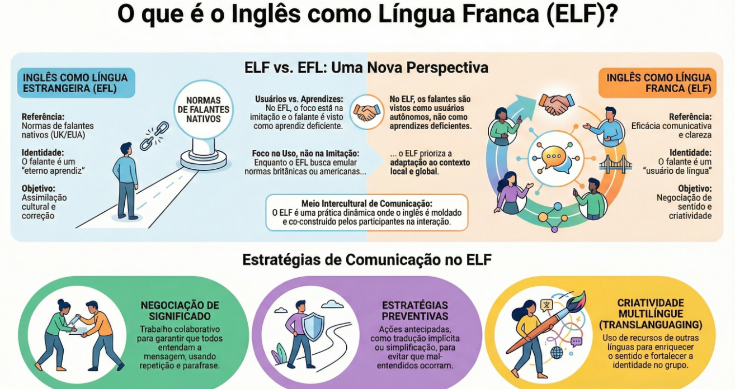

06. O infográfico apresenta uma comparação entre o Inglês como Língua Estrangeira (EFL) e o Inglês como Língua Franca (ELF), destacando diferenças quanto à identidade do falante, aos objetivos do ensino e às estratégias de comunicação.
A partir das informações verbais e visuais do infográfico, conclui-se que a principal mudança proposta pelo conceito de ELF em relação ao modelo tradicional de EFL é:

A) a substituição das normas gramaticais por uma comunicação sem regras definidas.
B) a valorização da pronúncia nativa como critério central para a eficácia comunicativa internacional.
C) a compreensão do inglês como prática dinâmica e intercultural, centrada na negociação de sentido e na eficácia comunicativa.
D) a eliminação da influência cultural na aprendizagem da língua inglesa em contextos globais.
E) a padronização do inglês global com base em normas britânicas e americanas para evitar mal-entendidos.

