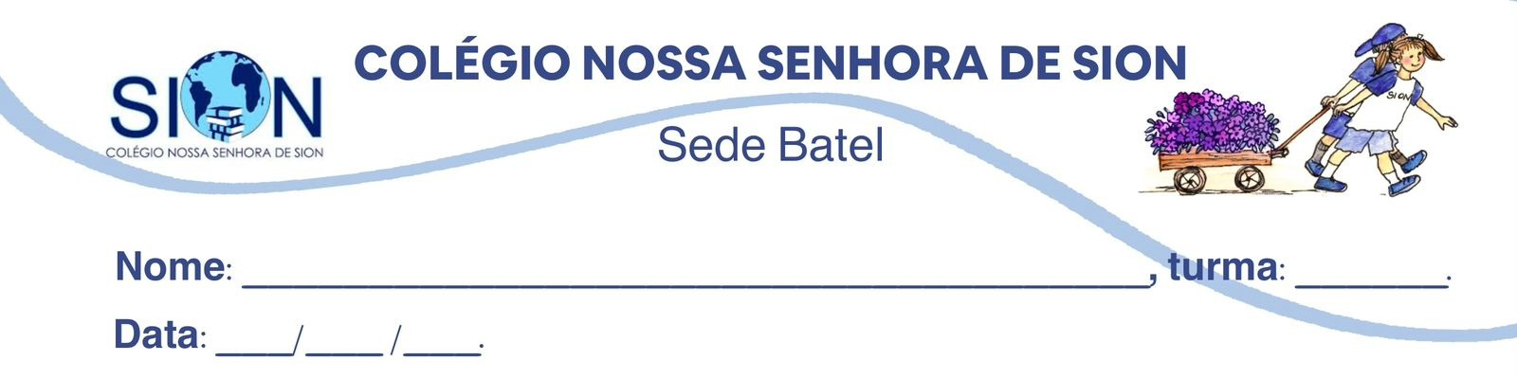

Subject English
Ms. Kauane
GUIDE LESSON– 3º GRADE – 1º TRIMESTER

Kevin Adkins almost kicked the Ice Age skull to the side because he thought it was just debris from a recent flood – then he saw that it had teeth.
When Kevin Adkins took his father-in-law, Tony Hager, on his first turkey hunt on May 8, 2022, the two West Virginians spotted an animal skull in a Putnam County creek. Covered in mud from a flood that had hit the region two days earlier, it was initially unidentifiable. So Adkins took it home – and later learned that it belonged to an 11,000-year-old giant sloth.
While 36-year-old Adkins had hunted turkeys in Putnam County plenty of times before, he had never come across something like this. Trudging through the muddy wilderness, the Red House resident and his father-in-law were primarily interested in nabbing some wild birds when they encountered the relic.
“We were running and gunning for toms,” Adkins told Outdoor Life. “We’d worked a gobbler for about 30 minutes, then the bird moved off, so we picked up and headed up the creek. I looked down in the middle of the creek as we crossed it and saw a big blob of something I thought was a root ball, so I almost kicked it away.”
“But I noticed something different about it and looked closer,” Adkins went on. “That’s when I saw some molar teeth, so I picked it up.”
Determined not to let the potential find of a lifetime distract from his turkey hunt, Adkins propped the skull next to the creek and forged ahead. When he and Hager concluded their hunt later that morning, they retrieved the skull and carried it home.
“[My wife] thought it was a cow skull because it was so big,” Adkins said. The skull weighed about 30 pounds and sported tufts of hair. It had four molar teeth on either side of its jawbone.
“But my father-in-law said no, it was something very different,” continued Adkins. “That’s when we started searching the internet, sending photos to family and friends, and then I posted it on social media. That really got things moving along with trying to ID what I’d found.”
(Available in: https://allthatsinteresting.com/tag/news.)

01. What was Kevin Adkins doing when he found the skull?
a) Fishing in the Putnam County creek
b) Searching for historical artifacts
c) Hunting turkeys with his father-in-law
d) Exploring the area after the flood

02. Why did Adkins almost kick the skull?
a) He thought it was a piece of tree root
b) He believed it was an old cow skull
c) He was afraid of wild animals nearby
d) He mistook it for a large rock

03. How does the sequence of events in the text highlight the role of social media in modern discoveries?
a) It shows that experts rely on social media to confirm all historical finds.
b) It emphasizes that public interest plays a major role in identifying artifacts.
c) It demonstrates that professional institutions no longer have control over discoveries.
d) It suggests that online platforms can replace traditional scientific methods.

04. What can be inferred about the significance of the skull based on its characteristics?
a) Its large size and weight indicated it was an extinct species.
b) The presence of hair meant it had been preserved in ice for thousands of years.
c) The condition of the skull suggested it was only a few hundred years old.
d) The missing jawbone made it difficult to determine the species.

05. Why does the author mention the recent flood in the story?
a) To explain why Adkins was searching for artifacts in the creek.
b) To suggest that climate events can expose long-hidden remains.
c) To highlight the dangers of hunting in unstable environments.
d) To imply that the flood caused the extinction of certain species.

06. How does the passage illustrate the relationship between chance and scientific discovery?
a) Many important findings are made accidentally by non-experts.
b) Only trained professionals are capable of making significant discoveries.
c) Scientific progress depends entirely on systematic research, not accidents.
d) Fossil discoveries rarely occur in everyday situations.

