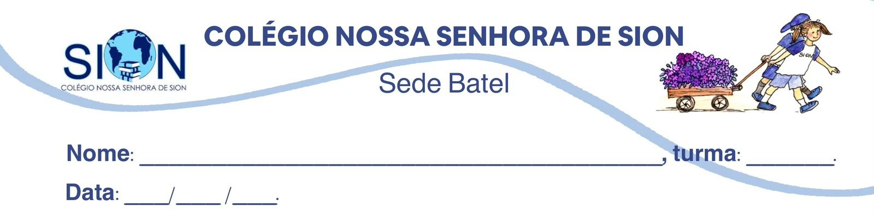

Subject English
Ms. Kauane
ENGLISH WORKSHEET– 3º GRADE – 1º TRIMESTER

Read text 1 and answer questions 01 to 07.
TEXT 1 – NEWS ARTICLE

Teen Volunteers Transform Abandoned Lot into Community Garden

Last year, a group of teenagers from a public school decided to take action when they noticed an abandoned lot in their neighborhood. The space, once filled with trash and broken furniture, had become a symbol of neglect. Instead of waiting for authorities to act, the students organized themselves and created a plan.
They started by cleaning the area, removing waste, and planting seeds. With support from local residents and small businesses, the initiative quickly gained attention. Within months, the empty lot had turned into a vibrant community garden, producing vegetables and herbs for families in need.
According to one of the students, Maria Lopez, the project was not only about improving the neighborhood but also about changing mindsets. “We wanted to show that young people can make a difference,” she said.
The project has inspired similar actions in nearby communities and has been recognized by local authorities as an example of civic engagement.

01. What problem did the teenagers identify in their neighborhood?
____________________________________________________________________________________________________________________________________________________________________________

02. What actions did they take to solve the problem?
____________________________________________________________________________________________________________________________________________________________________________

03. What was the result of their initiative?
____________________________________________________________________________________________________________________________________________________________________________

04. The word “neglect” in the text is closest in meaning to:
a) care
b) abandonment
c) attention
d) improvement

05. The expression “gained attention” suggests that the project:
a) failed quickly
b) became popular or noticed
c) lost support
d) was ignored

06. What is the main message of the text?
____________________________________________________________________________________________________________________________________________________________________________

07. Why is Maria Lopez’s quote important for the text?
____________________________________________________________________________________________________________________________________________________________________________

Read text 1 and answer questions 08 to 16.
TEXT 2 – POEM
Funeral Blues – W.H. Auden

Stop all the clocks, cut off the telephone,
Prevent the dog from barking with a juicy bone,
Silence the pianos and with muffled drum
Bring out the coffin, let the mourners come.

Let aeroplanes circle moaning overhead
Scribbling on the sky the message 'He is Dead'.
Put crepe bows round the white necks of the public doves,
Let the traffic policemen wear black cotton gloves.

He was my North, my South, my East and West,
My working week and my Sunday rest,
My noon, my midnight, my talk, my song;
I thought that love would last forever: I was wrong.

The stars are not wanted now; put out every one,
Pack up the moon and dismantle the sun,
Pour away the ocean and sweep up the wood;
For nothing now can ever come to any good.

08. What is the emotional tone of the poem?
______________________________________________________________________________________

09. What event motivates the speaker’s feelings?
____________________________________________________________________________________________________________________________________________________________________________

10. What does the speaker mean by “Stop all the clocks”?
____________________________________________________________________________________________________________________________________________________________________________

11. Why does the speaker describe the loved one as “my North, my South, my East and West”?
____________________________________________________________________________________________________________________________________________________________________________

12. What is the effect of the line: “I thought that love would last forever: I was wrong”?
____________________________________________________________________________________________________________________________________________________________________________

13. Identify one example of hyperbole in the poem: _____________________________________________

14. Identify one example of metaphor and explain its meaning: ______________________________________________________________________________________

15. The last stanza suggests:
a) hope for the future
b) indifference
c) total despair
d) acceptance

16. The exaggeration in the poem serves to:
a) create humor
b) minimize feelings
c) intensify grief
d) confuse the reader

