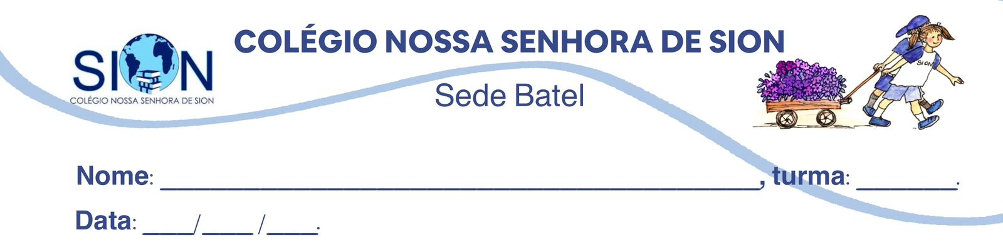
Componente Curricular de Geografia – 9 ano
Professora Morgana

Objetos de conhecimento: Globalização, Expansão do Capitalismo e Revoluções Industriais

- O que é Globalização?
____________________________________________________________________________________________________________________________________________________________________________________________________________________________________________________________________________________________________________

- Relacione as Grandes Navegações (entre os séculos XV e XVII) com o início do processo de globalização:
____________________________________________________________________________________________________________________________________________________________________________________________________________________________________________________________________________________________________________

- Cite e descreva uma desvantagem da globalização:
____________________________________________________________________________________________________________________________________________________________________________________________________________________________________________________________________________________________________________

- Cite e descreva uma vantagem da globalização:
____________________________________________________________________________________________________________________________________________________________________________________________________________________________________________________________________________________________________________

- Descreva as principais transformações da Primeira Revolução Industrial:
____________________________________________________________________________________________________________________________________________________________________________________________________________________________________________________________________________________________________________

- Descreva as principais transformações da Segunda Revolução Industrial:
____________________________________________________________________________________________________________________________________________________________________________________________________________________________________________________________________________________________________________

- Descreva as principais transformações da Terceira Revolução Industrial:
____________________________________________________________________________________________________________________________________________________________________________________________________________________________________________________________________________________________________________

- Relacione as três primeiras fases do capitalismo com suas características principais (capitalismo comercial, industrial e financeiro).
________________________________________________________________________________________________________________________________________________________________________________________________________________________________________________________________________________________________________________________________________________________________________________________________________________________________________________________________________________________________________________________________________________________________________________________________________________________
________________________________________________________________________________________________________________________________________________________________________________________________________________________________________________________________________________________________________________________________________________________________________________________________________________________________________________________________________________________________________________________________________________________________________________________________________________________

- A IA está ligada a quais revoluções industriais? Por quê?
____________________________________________________________________________________________________________________________________________________________________________________________________________________________________________________________________________________________________________

