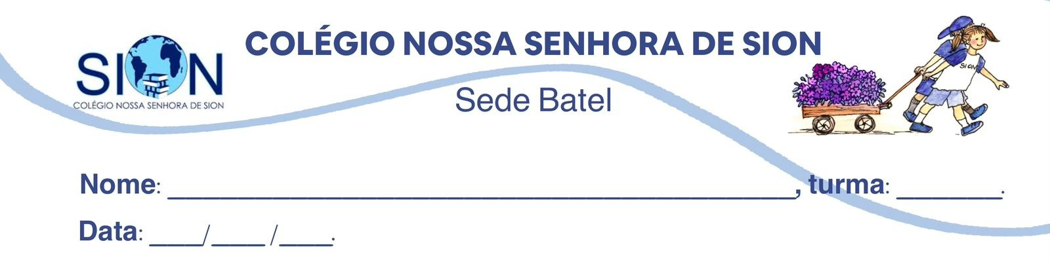

Subject English
Ms. Kauane
ENGLISH WORKSHEET– 3º GRADE – 1º TRIMESTER

Watch the video and answer the questions.

Linguists Explain Slang Trends Through History | WIRED (https://www.youtube.com/watch?v=ANc9F0p3mkw)

01. Match the slang terms or concepts (1-5) with their correct descriptions or origins (A-E) based on the video.

1- Dull pickle
2- On fleek
3- Booze
4- Chuggy
5- In-group marker

A. ( ) A term meaning "perfectly done" or "flawless," coined by a 17-year-old on Vine.
B. ( ) A 17th-century insult used to describe a dim-witted person or a "blockhead."
C. ( ) A function of slang that identifies someone as part of a specific social circle.
D. ( ) An old slang word for alcohol that originated from the Dutch word buysen.
E. ( ) A term used by Gen Z to describe millennials who are off-trend or "basic."

02. Decide if the following statements are True (T) or False (F) according to the video.

a) ( ) Slang terms tend to disappear quickly once they are adopted by people outside the original "in-group" (like "the olds").
b) ( )The acronym YOLO remained popular for several decades before becoming "cringe".
c) ( ) A dictionary of "thieves' cant" published in 1699 actually helped protect the secret language of criminals.
d) ( ) The word cool has remained popular for nearly a century because it can adapt to many different contexts.
e) ( ) Most slang terms can be traced back to a specific person who coined them.

03. Complete the sentences using information from the video.

a) The process of slang becoming mainstream and then immediately "passé" is often accelerated by ___________________ __________________.
b) According to the linguists, when _______________ ________________ did a segment called "What's your YOLO?", it was considered the "death knell" for that specific slang term.
c) The word cool was heavily popularized by ___________________ musicians in the 1940s, such as Lester Young.
d) Linguist Donna Joe Napoli suggests that "cool" survives because of its "____________________ nature".

04. According to the video, what is the historical significance of young Black women in relation to slang?

__________________________________________________________________________________________________________________________________________________________________________________________________________________________________________________________________

