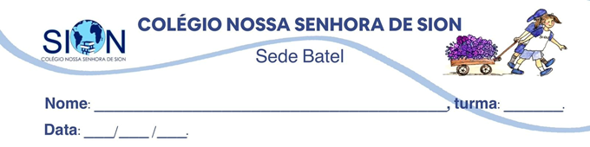
ENGLISH WORKSHEET– 2ª GRADE – 2º TRIMESTER

01. Make a glossary for the words below. Use Cambridge Dictionary.
catch: | win: | achieve:
perception: | awareness: | insight:
opposite: | opposed: | contrary:
care: | bother: | desire:
concludes: | reasons: | argues:
misguided: | misled: | misdirected:
error: | doubt: | illusion:
expand: | spread: | widen:

