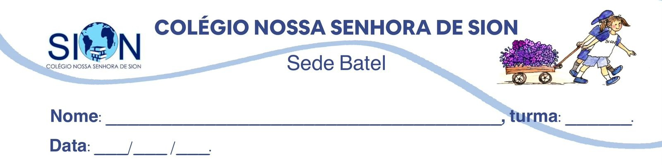

Subject English
Ms. Kauane
TEST REVIEW– 2º GRADE – 2º TRIMESTER

01. Complete the sentences with the Past Perfect
Use had + past participle (VERB ED)

a) I __________________________ my homework before dinner. (finish)
b) She __________________________ the movie before her friends arrived. (watch)
c) They __________________________ the house when the storm started. (leave)
d) We __________________________ breakfast before we went to school. (eat)
e) He __________________________ his keys before he found them in his bag. (lose)
f) The teacher __________________________ the lesson before the students asked questions. (explain)

02. Put the verbs in the correct tense: Past Perfect or Simple Past
a) When I _______________________ at school, the class _____________________. (arrive / start)
b) She _______________________ happy because she _______________________ the exam. (be / pass)
c) After we _______________________ lunch, we _______________________ to the park. (have / go)
d) By the time the teacher _______________________, the students ______________ the activity. (come / finish)

03. Match the first part with the correct ending.
1. When I arrived at the party, | a. because he had lost his phone.
2. She was nervous | b. the movie had already started.
3. He was upset | c. because she had never spoken in public before.
4. By the time we got to the cinema, | d. after they had finished their homework.
5. The students played soccer | e. everyone had eaten the cake.

1- _____ 2- _____ 3- _____ 4-_____ 5- _____

04. Identify the first action. Read the sentences and write the action that happened first.

a) When I arrived at school, the class had started.
First action: __________________________________
b) After she had cleaned her room, she listened to music.
First action: __________________________________
c) By the time we got home, my mother had cooked dinner.
First action: __________________________________
d) He was sad because he had lost the game.
First action: __________________________________

05. Match the words to their meanings
Word | Meaning
1. concentrate | a. very strong
2. senses | b. a method or way to do something
3. technique | c. to focus your attention
4. studies | d. the abilities to see, hear, smell, taste and touch
5. powerful | e. school or academic work
6. controls | f. manages or directs something

06. Choose the word with a similar meaning.

receive
a) lose
b) get
c) forget

achieve
a) accomplish
b) sleep
c) break

awareness
a) mistake
b) noise
c) knowledge

hope
a) wish
b) error
c) doubt

expand
a) grow
b) stop
c) hide

misinformed
a) given wrong information
b) very strong
c) very happy

ANSWERS
01.
a) had finished
b) had watched
c) had left
d) had eaten
e) had lost
f) had explained

02.
a) arrived / had started
b) was / had passed
c) had had / went
d) came / had finished

03.
1-e — When I arrived at the party, everyone had eaten the cake.
2-c — She was nervous because she had never spoken in public before.
3-a — He was upset because he had lost his phone.
4-b — By the time we got to the cinema, the movie had already started.
5-d — The students played soccer after they had finished their homework.

04.
a) The class had started.
b) She had cleaned her room.
c) My mother had cooked dinner.
d) He had lost the game.

05.
1-c— concentrate: to focus your attention
2-d — senses: the abilities to see, hear, smell, taste and touch
3-b — technique: a method or way to do something
4-e — studies: school or academic work
5-a — powerful: very strong
6-f — controls: manages or directs something

06.
a) receive — get
b) achieve — accomplish
c) awareness — knowledge
d) hope — wish
e) expand — grow
f) misinformed — given wrong information

