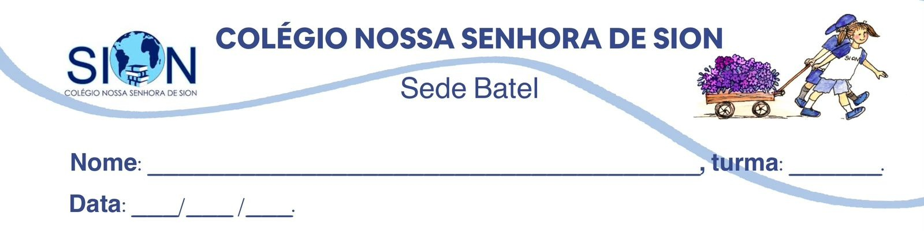

Subject English
Ms. Kauane
GUIDE LESSON– 3º GRADE – 2º TRIMESTER

Text 1
Read the text below and answer questions 01 to 04.

Last Friday, Emma had planned an outdoor birthday party for her grandmother. She had invited the whole family, decorated the garden and prepared a playlist with her grandmother’s favorite songs. However, just one hour before the party, it started raining cats and dogs. At first, Emma looked disappointed. Her brother said, “Well, every cloud has a silver lining. We can move everything inside and make it a cozy family gathering.”
Emma agreed, although she was already snowed under with last-minute tasks. She had to move the food, call the guests and rearrange the living room. In the end, the party was a success. Her grandmother was on cloud nine, smiling and laughing all evening.

01. According to the text, the expression “raining cats and dogs” means that:

A. animals were outside during the party.
B. the weather was extremely cold.
C. it was raining very heavily.
D. the rain stopped unexpectedly.
E. the garden was full of pets.

02. In the sentence “every cloud has a silver lining,” Emma’s brother is trying to:

A. criticize Emma for planning an outdoor event.
B. suggest that something positive may come from a bad situation.
C. explain that the rain will stop immediately.
D. say that clouds are beautiful during storms.
E. convince Emma to cancel the birthday party.
03. The expression “snowed under” in the text indicates that Emma:

A. was trapped outside because of the weather.
B. felt very cold during the party.
C. had too many things to do at the same time.
D. decided to ignore the problem.
E. was extremely happy with the situation.

04. The sentence “Her grandmother was on cloud nine” means that her grandmother was:

A. confused.
B. nervous.
C. extremely happy.
D. disappointed.
E. angry.

Text 2
Read the text and answer questions 05 to 08.

Many students dream about getting into top universities, but some of them keep their heads in the clouds. They imagine success without discipline, effort or planning. However, preparing for entrance exams requires much more than optimism. Students need to organize their study routine, review difficult topics and practice under exam conditions.
There will certainly be stressful moments, and candidates may feel snowed under by deadlines, assignments and mock tests. Still, a difficult period can teach valuable lessons. As the saying goes, every cloud has a silver lining: pressure can help students discover their strengths and improve their time management skills.

05. The main purpose of the text is to:

A. discourage students from applying to universities.
B. explain that success depends only on positive thinking.
C. criticize all students who feel stressed before exams.
D. show that preparation for exams requires realism, discipline and organization.
E. argue that entrance exams should be easier.

06. In the text, students who have their “heads in the clouds” are described as people who:

A. study efficiently and realistically.
B. have unrealistic ideas about success.
C. are afraid of taking exams.
D. are excellent at planning their routine.
E. refuse to be optimistic.

07. The connector “However” in the first paragraph introduces:

A. a contrast between dreaming and the need for effort.
B. a consequence of being organized.
C. an example of a successful student.
D. a repetition of the previous idea.
E. a conclusion about university life.

08. In the sentence “pressure can help students discover their strengths,” the modal verb “can” expresses:

A. prohibition.
B. obligation.
C. possibility.
D. certainty.
E. permission.

09. Writing: Read the situation below.
Your friend failed an important mock exam and now believes they will never pass the university entrance exam. Write a short message in English giving advice and using at least two of the idiomatic expressions below:

every cloud has a silver lining
head in the clouds
snowed under
cloud nine
face like thunder
raining cats and dogs

Your text must have 80 to 120 words.

