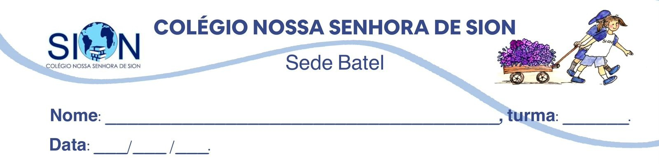

Subject English
Ms. Kauane
REVIEW– 1º GRADE – 2º TRIMESTER

01. Match each description to the correct artistic form.

( ) A story published as a long fictional book. | a) Sculpture
( ) A work created by shaping stone, wood, metal, or another material. | b) Protest album
( ) A performance in which artists use body movements to communicate ideas. | c) Novel
( ) A production that combines images, dialogue, music, and acting for television. | d) Interactive exhibition
( ) An artistic event in which visitors can interact with digital elements. | e) Television series
( )A musical work created to criticise injustice or demand social change. | f) Dance performance

02. Complete the sentences with the expressions below. Use each expression only once.

entertain audiences – express emotions – preserve traditions – communicate messages – question society – inspire change

a) Traditional songs and dances can help communities ____________________________.
b) Comedies are often created to ____________________________ and make people laugh.
c) Some artists use their work to ____________________________ and encourage people to reflect on injustice.
d) A painter may use colour and form to ____________________________ that are difficult to explain in words.
e) Protest music can ____________________________ about political and social problems.
f) Powerful works of art can motivate communities and ____________________________.

03. Read the text.
Can AI Replace Human Creativity?

Artificial intelligence can produce images, texts, music, and animations in a short period of time. This ability has created an important debate in the artistic world. Some people believe that AI is a useful tool that can support artists during the creative process. Others fear that companies may use it to replace creative professionals.
Human creativity, however, is strongly connected to personal experience, emotion, curiosity, and individual choices. A machine can recognise patterns and reproduce certain styles, but it does not experience the world as a human being does. For this reason, many artists argue that AI works best when it is guided and controlled by people.

Answer the questions.

a) What two opposing views about AI are presented in the text?
____________________________________________________________________________________________________________________________________________________________________________
b) Why are some creative professionals worried about AI?
____________________________________________________________________________________________________________________________________________________________________________
c) Which four human qualities are connected to creativity in the text?
____________________________________________________________________________________________________________________________________________________________________________
d) What can AI recognise and reproduce?
____________________________________________________________________________________________________________________________________________________________________________

e) What is the writer’s main purpose?

( ) To prove that AI should replace artists.
( ) To present both the possibilities and limitations of AI.
( ) To explain how to create digital images.
( ) To argue that technology has no place in art.

04. Read the statements and classify them as:

A – Advantage
D – Disadvantage
L – Limitation

a) AI may help architects analyse sunlight, shadows, and window positions. ______
b) AI may replace some jobs in the animation industry. ______
c) AI cannot reproduce all the emotional and original elements of human creativity. ______
d) An AI system could learn an animator’s style and work as an assistant. ______
e) AI cannot independently provide a complete creative solution. ______

05. Understanding Manifestos - Choose the correct alternative.

A manifesto is best described as:

a) a private letter about personal problems.
b) a public declaration of beliefs, intentions, or objectives.
c) a fictional text with imaginary characters.
d) a list of historical events.

Manifestos may be written by:

a) only political parties.
b) only professional artists.
c) groups, communities, organisations, and movements.
d) only government institutions.

One purpose of a manifesto is to:

a) hide the beliefs of a group.
b) avoid discussing social problems.
c) unite people around shared ideas.
d) describe events without expressing an opinion.

A manifesto normally presents:

a) common principles and goals.
b) instructions for a scientific experiment.
c) a conversation between characters.
d) information about a person’s daily routine.

06. Read the fictional manifesto.

The Young Artists’ Manifesto

We believe that art should be accessible to everyone, regardless of age, income, or background. Museums, theatres, and cultural centres must create more opportunities for young people to participate.

We reject the idea that only professional artists can produce meaningful work. Creativity also belongs to students, amateur artists, local communities, and people whose voices are rarely represented.

We will use painting, music, dance, literature, and digital art to communicate our experiences, preserve our traditions, and question social inequality. Art must not remain distant from everyday life. It must become a force for participation and positive change.

Answer the questions.

a) What is the group’s main belief about access to art?
____________________________________________________________________________________________________________________________________________________________________________
b) Which traditional idea does the group reject?
____________________________________________________________________________________________________________________________________________________________________________
c) Who should have the opportunity to produce meaningful art?
____________________________________________________________________________________________________________________________________________________________________________
d) Mention four artistic forms included in the manifesto.
____________________________________________________________________________________________________________________________________________________________________________
e) What three purposes of art are mentioned in the final paragraph?
____________________________________________________________________________________________________________________________________________________________________________

07. Identify the head noun and the words that add information.

Noun phrase | Head noun | Words that add information
a powerful protest song
those interactive digital exhibitions
her unusual artistic style
three talented young musicians
the international film festival

Now answer:

a) Which phrase contains a possessive adjective?
______________________________________________________________________________________
b) Which phrase contains a number?
______________________________________________________________________________________
c) Which phrases contain more than one adjective?
______________________________________________________________________________________

08. Rewrite the phrases in the correct order.

a) a sculpture impressive modern
______________________________________________________________________________________
b) those paintings colourful abstract
______________________________________________________________________________________
c) an exhibition digital interactive
______________________________________________________________________________________
d) her project creative new
______________________________________________________________________________________

09. Correct the mistakes. Rewrite the sentences.

a) They visited two moderns museums.
______________________________________________________________________________________
b) The gallery displayed several paintings colourful.
______________________________________________________________________________________
c) We watched three interestings performances.
______________________________________________________________________________________

10. Complete the compound adjectives with the correct words.

award – five – full – internationally – thought – well

a) a ____________________-known painter
b) an ____________________-winning film
c) a ____________________-provoking exhibition
d) a ____________________-minute performance
e) an ____________________-recognised musician
f) a ____________________-length documentary

