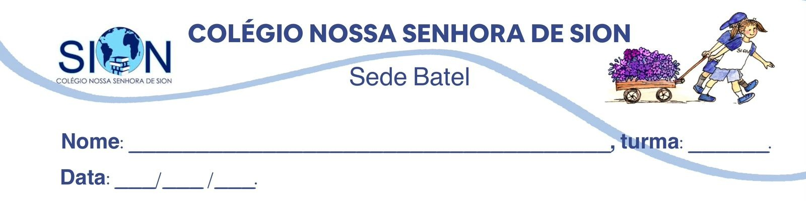

Subject English
Ms. Kauane
REVIEW– 2º GRADE – 2º TRIMESTER

01. Match the script elements to their definitions.

( ) Title | a) The people who participate in the story.
( ) Characters | b) The name that identifies the play, film, scene or video.
( ) Setting | c) The information that explains where and when the action happens.

02. Now identify the element represented by each example.
TITLE – CHARACTERS - SETTING

a) The Mysterious Phone Call: ____________________________
b) A bus station late at night: ____________________________
c) Mia – a journalist / Daniel – her brother: ____________________________

03. Complete the sentences with dialogue or stage directions.

a) ____________________________ show the conversation between characters.
b) ____________________________ describe actions, emotions, movements and tone of voice.
c) The character’s name usually appears before the ____________________________.
d) Sounds and lighting may be included in the ____________________________.
e) ____________________________ are often written in parentheses, brackets or italics.

04. Choose the correct alternative.

An act is:
a) a short conversation between two characters.
b) a major part of a play.
c) a description of the setting.
d) a character’s emotional reaction.

A scene is usually:
a) longer than the entire play.
b) a list of all the characters.
c) a smaller section that happens in one place or period of time.
d) the title of the script.

Which option is correctly organised?
a) Scene 2 – Character 1
b) Act 1 – Setting 3
c) Act 1 – Scene 2
d) Dialogue 1 – Act 2

A play changes from a classroom in the morning to a park in the afternoon. What would probably change?
a) The title
b) The scene
c) The list of characters
d) The genre

05. Read the excerpt.

The Missing Notebook

Characters:
LILY – a high school student
ETHAN – Lily’s classmate

Setting: The school library during lunchtime.

ACT 1 – SCENE 1

(Lily enters the library quickly and looks around.)

LILY: Ethan, have you seen my English notebook?
ETHAN: (closing his book) No, but you had it during the first lesson.
LILY: I know. I think I left it in the science laboratory.
ETHAN: Let’s look for it before the next class starts.
Identify one example of each element.

a) Title: ________________________________________________________
b) Character: ____________________________________________________
c) Setting: ______________________________________________________
d) Stage direction: _______________________________________________
e) Dialogue: _____________________________________________________
f) Act and scene: _________________________________________________

06. Read the script excerpt from Exercise 05 again and answer the questions.

a) Where does the scene take place?
_________________________________________________________________________________
b) What problem does Lily have?
_________________________________________________________________________________
c) Where does she think her notebook is?
_________________________________________________________________________________
d) What does Ethan suggest?
_________________________________________________________________________________
e) What does the stage direction “closing his book” show about Ethan’s action?
_________________________________________________________________________________

07. Complete the sentences using the zero conditional and the correct form of the verbs in brackets.

Structure: If + Simple Present, Simple Present

a) If people ____________________ enough water, they often feel tired.
(not drink)
b) Plants usually ____________________ if they do not receive enough sunlight.
(die)
c) If you ____________________ oil and water, they do not combine.
(mix)
d) A smartphone stops working if its battery ____________________ completely.
(run out)
e) If children ____________________ enough sleep, they find it difficult to concentrate.
(not get)
f) Ice ____________________ if you leave it in a warm place.
(melt)

08. Complete the sentences using the first conditional and the correct form of the verbs in brackets.

Structure: If + Simple Present, will + base verb

a) If the weather improves tomorrow, we ____________________ to the beach.
(go)
b) Sarah ____________________ the train if she does not leave home soon.
(miss)
c) If you ____________________ your assignment by Friday, the teacher will not accept it.
(not submit)
d) My parents will be worried if I ____________________ them tonight.
(not call)
e) If Daniel studies consistently, he ____________________ the entrance exam.
(pass)
f) We ____________________ the picnic indoors if it rains this afternoon.
(have)

09. Choose the correct alternative. Second Conditional.

If I ______ more free time, I would learn another language.

a) have
b) had
c) will have
d) had had

Emma would travel around the world if she ______ enough money.
a) saves
b) will save
c) saved
d) had saved

If we lived closer to the city centre, we ______ public transport more often.
a) use
b) will use
c) would use
d) would have used

What would you do if you ______ a valuable object in the street?
a) find
b) found
c) had found
d) will find

If Mark ______ so impatient, he would make better decisions.
a) is not
b) were not
c) had not been
d) will not be

They would participate in the competition if they ______ more confident.
a) feel
b) felt
c) had felt
d) will feel

10. Complete the conditionals with your own words.

e) Zero conditional
If people do not set an alarm, they sometimes
____________________________________________________________________.

f) First conditional
If Olivia travels again next month, she
____________________________________________________________________.

g) Second conditional
If I were in Olivia’s situation, I
____________________________________________________________________.

h) Third conditional
If Olivia had set an alarm, she
____________________________________________________________________.

