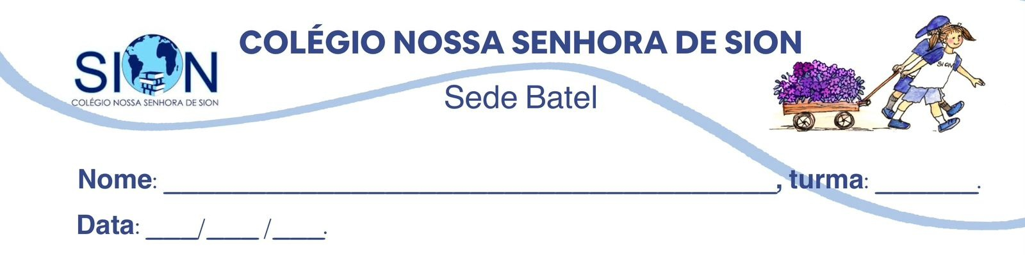

Subject English
Ms. Kauane
REVIEW– 3º GRADE – 2º TRIMESTER

01. Match the idioms to their correct meanings.

( ) It’s raining cats and dogs.
( ) Snowed under
( ) On cloud nine

a) Extremely happy about something.
b) Having too much work or too many responsibilities.
c) Raining very heavily.

02. omplete the sentences with the expressions below. Use each expression only once.

every cloud has a silver lining – head in the clouds – face like thunder

a) Lucas believed he could pass the exam without studying. He clearly had his _______________________.

b) When the coach saw that the team had ignored his instructions, he had a _________________________.

c) Losing the competition was disappointing, but it motivated us to practise harder. As people say, ____________________________.

03. Explain in your own words what the expression “every cloud has a silver lining” teaches us about difficult situations.
__________________________________________________________________________________________________________________________________________________________________________________________________________________________________________________________________

04. Read the text and answer the questions .

A Difficult Week

Emma had been snowed under with school projects for several days. On Thursday morning, it was raining cats and dogs, so the school sports competition was cancelled. Her coach had a face like thunder because the team had trained for weeks. However, Emma tried to remain positive. She believed that every cloud had a silver lining because the cancellation gave the team more time to prepare. When the competition was finally held, Emma’s team won, and everyone was on cloud nine.

a) Why was Emma snowed under?
______________________________________________________________________________________

b) Why did the coach have a face like thunder?
______________________________________________________________________________________
c) What was the positive consequence of the competition being cancelled?
______________________________________________________________________________________
d) Which expression shows that the team was extremely happy?
______________________________________________________________________________________
e) What does the text suggest about Emma’s attitude towards problems?
______________________________________________________________________________________

05. Choose the correct alternative.

Sustainability refers to:

a) using all available resources as quickly as possible.
b) using resources in a way that can continue without causing serious harm.
c) avoiding all forms of production and consumption.
d) replacing renewable energy with fossil fuels.

An activity is considered unsustainable when:

a) resources are replaced faster than they are used.
b) it protects nature and reduces pollution.
c) it uses resources faster than they can be replaced.
d) it improves living conditions.

According to the concept presented in the material, renewable energy is sustainable because:

a) it can potentially continue without running out.
b) it produces more waste than traditional energy.
c) it depends entirely on limited resources.
d) it prevents people from using electricity.

What is likely to happen when resources run out?

a) The activity will become more profitable.
b) The activity will not be able to continue.
c) The resources will immediately be replaced.
d) The environmental impact will disappear.

06. Complete the sentences with the words or expressions below.

resources – renewable – harm – replaced – run out – carry on

a) Solar and wind power are examples of ____________________________ energy.
b) If natural materials are consumed too quickly, they may eventually ____________________________.
c) Sustainable activities should not cause serious ____________________________ to the environment or society.
d) Water, forests and minerals are examples of natural ____________________________.
e) Some resources can be naturally ____________________________, while others take millions of years to form.
f) A company cannot ____________________________ producing an item if the necessary materials are no longer available.

07. Classify each action as Environmental (E), Social (S), Economic (EC) or More than one area (M).

a) Providing employees with safe working conditions. ______
b) Reducing water consumption in factories. ______
c) Producing durable goods that can be sold for many years. ______
d) Offering educational programmes to disadvantaged communities. ______
e) Using clean energy while maintaining responsible production. ______
f) Paying workers fairly and reducing pollution. ______
g) Avoiding food waste in a school cafeteria. ______

08. Read the text and mark the statements True (T), False (F) or Not Mentioned (NM).

What Makes a Brand Sustainable?

Sustainable brands try to reduce their negative impact on both the environment and society. They may use recycled or responsibly sourced materials, reduce carbon emissions, save water and energy, and provide safe working conditions. They can also produce durable goods and use reusable packaging. However, advertising alone does not prove that a company is sustainable. Consumers should look for certifications, detailed reports and specific environmental goals.

a) Sustainable brands are only concerned about the environment. ______
b) A sustainable brand may use recycled materials. ______
c) Durable products can contribute to sustainability. ______
d) Every company that uses reusable packaging is completely sustainable. ______
e) Consumers should evaluate evidence instead of trusting advertisements alone. ______
f) Sustainable brands always sell more expensive products. ______
g) Find one expression in the text that means “materials obtained in a responsible way.”
h) Why are certifications and reports important when evaluating a brand?

8. Complete the expressions with the correct word.

conditions – emissions – goals – materials – packaging – products – waste

a) responsibly sourced ____________________________
b) carbon ____________________________
c) safe working ____________________________
d) durable ____________________________
e) reusable ____________________________
f) reduce ____________________________
g) specific environmental ____________________________

