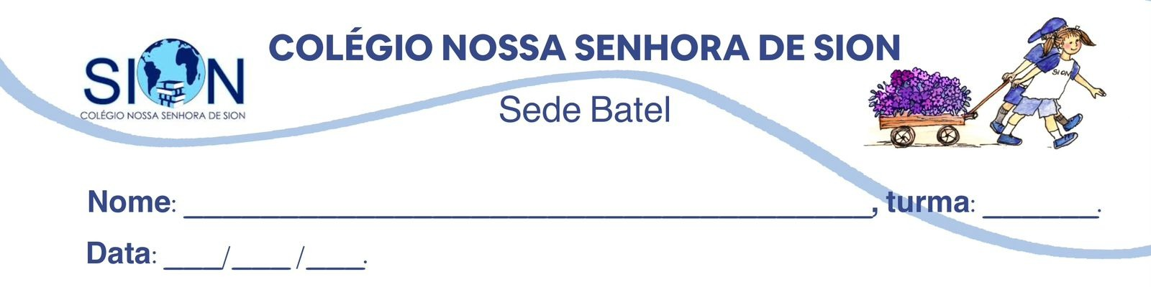

Subject English
Ms. Kauane
REVIEW– 7º GRADE – 2º TRIMESTER

01. Create a mind map covering the content from Units 3 and 4. Your mind map must include the vocabulary and grammar points from each unit.

02. Find all the words in the following word search.
AFRAID – BORED – UPSET – WORRIED – CAREGIVER – LAWYER – PARAMEDIC – VOLUNTEER
