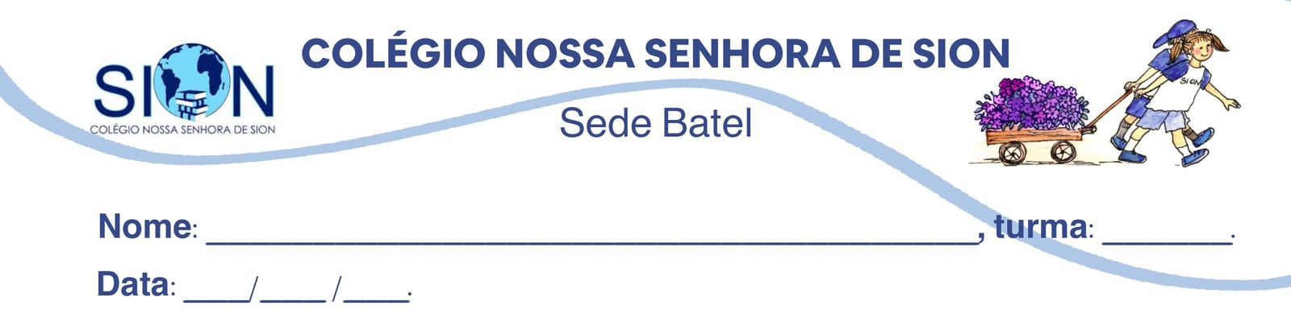Filosofia – 1ª Série EM
Professor Gabriel
Guia de Revisão de Filosofia: Felicidade, prazer, sofrimento e alienação.

1. Na sua opinião, qual é a função da arte?

_________________________________________________________________________________________ _________________________________________________________________________________________
_________________________________________________________________________________________
_________________________________________________________________________________________
__________________________________________________________________________________________________________________________________________________________________________________
_________________________________________________________________________________________

2. Qual tipo de Arte ou conteúdo artístico você mais consome?

__________________________________________________________________________________________________________________________________________________________________________________
_________________________________________________________________________________________

3. Pesquise o significado que a palavra catarse tem no contexto das artes. Registre-o abaixo.

__________________________________________________________________________________________________________________________________________________________________________________
_________________________________________________________________________________________

4. Na sua opinião, a arte pode produzir alienação? E conscientização? Explique.

_________________________________________________________________________________________ _________________________________________________________________________________________
_________________________________________________________________________________________
_________________________________________________________________________________________
__________________________________________________________________________________________________________________________________________________________________________________
_________________________________________________________________________________________

5. Você acredita que a arte pode trazer felicidade? Explique.

__________________________________________________________________________________________________________________________________________________________________________________
__________________________________________________________________________________________________________________________________________________________________________________
_________________________________________________________________________________________
6. Na sua opinião, o que torna um conteúdo artístico “bom”?

__________________________________________________________________________________________________________________________________________________________________________________
__________________________________________________________________________________________________________________________________________________________________________________
_________________________________________________________________________________________

7. Você vê valor em uma produção artística que te cause sofrimentos como “angústia”, ansiedade, etc? Explique.

__________________________________________________________________________________________________________________________________________________________________________________
_________________________________________________________________________________________
__________________________________________________________________________________________________________________________________________________________________________________
_________________________________________________________________________________________

