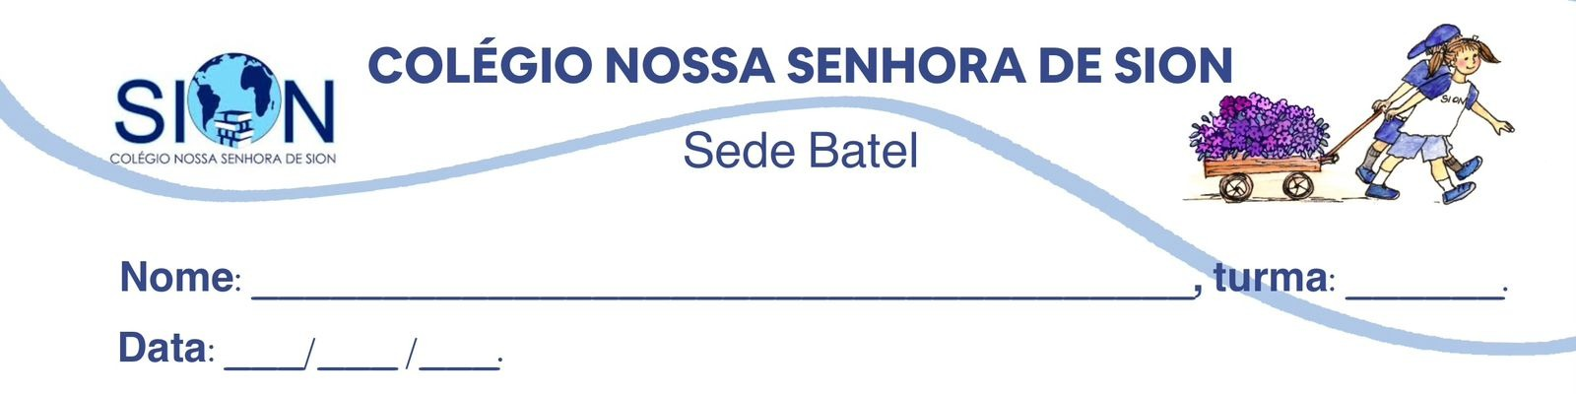

Subject English - Ms. Kauane
GUIDE LESSON– 1º GRADE – 3º TRIMESTER

RISING SEAS WILL THREATEN 1.5 MILLION AUSTRALIANS BY 2050 - REPORT
15 September 2025 By: Lana LamSydney

One and a half million Australians living in coastal areas are at risk from rising sea levels by 2050, a landmark climate report has warned.  Australia's first National Climate Risk Assessment predicted more frequent and severe climate hazards like floods, cyclones, heatwaves, droughts and bushfires.  "Australians are already living with the consequences of climate change today," Climate Change Minister Chris Bowen said, "but it's clear every degree of warming we prevent now will help future generations avoid the worst impacts in years to come."  The report looked at three global warming scenarios - above 1.5C, above 2C and above 3C.  Australia - one of the world's biggest polluters per capita - has already reached warming of above 1.5C, the report said, noting that at 3C, heat-related deaths in Sydney may rise by more than 400% and almost triple in Melbourne.  The 72-page report - released days before the government announces its emissions reduction targets for 2035 - found that no Australian community will be immune from climate risks that will be "cascading, compounding and concurrent".  It warned of more heatwave-related deaths, poorer water quality due to severe flooding and bushfires, and a A$611bn ($406bn; £300bn) drop in property values.  By 2050, the report found the number of coastal communities located in "high and very high risk areas" in Australia will increase and if populations levels remain stable, this will mean more than 1.5 million people will be at risk.  Areas in northern Australia, along with remote communities and outer suburbs of major cities, were particularly at risk, the report said. | "This will put pressure on health, critical infrastructure, natural species and ecosystems, and primary industries," the report warned, as well as posing extra challenges for emergency responders.  The report also found that coral reefs such as the Great Barrier Reef in Queensland and Ningaloo Reef in Western Australia - both already hit by record bleaching events - will face higher risks of "bleaching and biodiversity loss" due to warmer oceans.  "One thing that is very clear from this climate assessment is that our whole country has a lot at stake," Bowen said. "The cost of inaction will always outweigh the cost of action."  In response to the report, the government released a national adaptation plan which detailed how federal, state and local governments can work together to tackle climate issues, according to Bowen.  "We will also set an ambitious and achievable 2035 target, informed by advice from the independent Climate Change Authority," he said, referring to the body that provides advice on climate policy.  Australia has pledged to reduce emissions by 43% by 2030, but is criticised for its continued heavy reliance on fossil fuels.  Climate Council chief executive Amanda McKenzie said the report's findings were terrifying and called on the government to commit to higher emissions cuts.  "Australia cannot afford a timid 2035 target when our own government data shows the catastrophic costs of inaction," the head of the the non-profit said.  "The longer we delay the deep and sustained cuts to climate pollution we need, the harder it becomes to protect communities from escalating heatwaves, floods and bushfire weather."

01. What is the main focus of the report mentioned in the article?

a) Tourism in Australia
b) Climate risks and their impacts on Australians
c) Political debates in Sydney
d) Australia’s education system

02. Mark the following statements as True (T) or False (F).

a) ( ) One and a half million Australians are at risk from rising sea levels by 2050.
b) ( )The report only studied warming of above 3C.
c) ( )Sydney could see heat-related deaths increase by more than 400% at 3C warming.
d) ( )The report says all Australian communities will be safe from climate risks.

03. According to the text, what are some of the climate hazards predicted by Australia’s first National Climate Risk Assessment?
________________________________________________________________________________________________________________________________________________________________________________________________________________________________________________________________________

04. Match the words with their closest meaning based on the text:

( ) Cascading
( )Compounding
( )Emissions
( )Biodiversity

a) Variety of life forms
b) Related to releasing gases like CO₂
c) Increasing effects that build on each other
d) Falling one after another like a chain reaction

05. Who does the pronoun “he” in the sentence “We will also set an ambitious and achievable 2035 target, informed by advice from the independent Climate Change Authority,” he said refer to?
________________________________________________________________________________________________________________________________________________________________________________________________________________________________________________________________________

06. Chris Bowen said: “The cost of inaction will always outweigh the cost of action.”
What does he mean by this statement in the context of climate change?
________________________________________________________________________________________________________________________________________________________________________________

07. According to the report, what are some consequences of rising global warming to Australia’s ecosystems and human communities?
________________________________________________________________________________________________________________________________________________________________________________________________________________________________________________________________________

08. Find a prepositional phrase in the text. Transcribe it here.
________________________________________________________________________________________________________________________________________________________________________________________________________________________________________________________________________________________________________________________________________________________________

