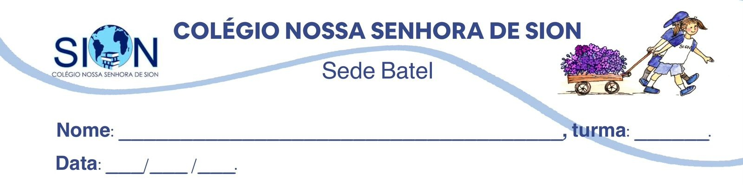

Subject English - Ms. Kauane
GUIDE LESSON– 2º GRADE – 3º TRIMESTER

Israel Travel Guide
Israel has always been a standout destination. From the days of prophets to the modern day nomad this tiny slice of land on the eastern Mediteranean has long attracted visitors. While some arrive in the ‘Holy Land’ on a spiritual quest, many others are on cultural tours, beach holidays and eco-tourism trips. Weeding through Israel’s convoluted history is both exhilarating and exhausting. There are crumbling temples, ruined cities, abandoned forts and hundreds of places associated with the Bible. And while a sense of adventure is required, most sites are safe and easily accessible. Most of all, Israel is about its incredibly diverse population. Jews come from all over the world to live here, while about 20% of the population is Muslim. Politics are hard to get away from in Israel as everyone has an opinion on how to move the country forward — with a ready ear you’re sure to hear opinions from every side of the political spectrum.

01. Antes de viajar, turistas geralmente buscam informações sobre o local para onde pretendem ir. O trecho do guia de viagens de Israel:

a) descreve a história desse local para que turistas valorizem seus costumes milenares.
b) informa hábitos religiosos para auxiliar turistas a entenderem as diferenças culturais.
c) divulga os principais pontos turísticos para ajudar turistas a planejarem sua viagem.
d) recomenda medidas de segurança para alertar turistas sobre possíveis riscos locais.
e) apresenta aspectos gerais da cultura do país para continuar a atrair turistas estrangeiros.

One of the things that made an incredible impression on me in the film was Frida’s comfort in and celebration of her own unique beauty. She didn’t try to fit into conventional ideas or images about womanhood or what makes someone or something beautiful. Instead, she fully inhabited her own unique gifts, not particularly caring what other people thought. She was magnetic and beautiful in her own right. She painted for years, not to be a commercial success or to be discovered, but to express her own inner pain, joy, family, love and culture. She absolutely and resolutely was who she was. The trueness of her own unique vision and her ability stand firmly in her own truth was what made her successful in the end.

02. A autora desse comentário sobre o filme Frida mostra-se impressionada com o fato de a pintora:
a) ter uma aparência exótica.
b) vender bem a sua imagem.
c) ter grande poder de sedução.
d) assumir sua beleza singular.
e) recriar-se por meio da pintura.

Text A
So, do we need to fuss over climate change or are we safe for generations to come? Are we unnecessarily worried? Can we indeed, predict the future of our planet? The biggest transformations don’t occur overnight but rather over hundreds of billions of years. Supercontinents change, mass extinctions annihilate almost all life, and alterations in the encompassing solar system all have an effect.
It is basically the sun that will decide the fate of our planet. In billions of years, as our ageing star begins to exhaust hydrogen fuel, it will transform into a red giant and broaden out into the inner solar system as remote as the Earth’s orbit.

Text B
Our Planet As far as we know, the earth is our only viable habitat. But for how long though?
We often make predictions about the weather - will it rain tomorrow, will it be sunny at the weekend? We can only contemplate the bigger questions though, such as, will the greenhouse gases in our atmosphere reach an upper limit and start to diminish? Will the earth become a mass of burning rock like Venus, or a frozen wasteland like Mars?

03. GLOSSARY: Make a glossary with the words underlined in the text. Check the meanings in the Cambridge Dictionary. Add an extra word at the end of the glossary.

WORD | MEANING

04. COMPREHENSION: Make four text interpretation questions about texts 1 and 2. Your classmates will have to answer them.

